**Parallel and Distributed Computing: A Modern Approach to High-Performance Systems**

Md. Mostafizur Rahman1

Md. Rakibul Hasan Rakib2

Md. Rakib Hosain porosh3

Arbi Akther4

Department of Computer Science and Engineering, State University of Bangladesh, South Purbachal, Kanchan, Dhaka-1461, Bangladesh*

## ****Abstract****

Parallel and Distributed Computing (PDC) has become a cornerstone of modern computer science, enabling the efficient execution of large-scale and complex computational tasks. Unlike traditional sequential computing, which processes one task at a time, PDC exploits concurrency and resource sharing to improve performance, scalability, and reliability. **Parallel computing** focuses on dividing tasks into smaller sub-tasks that run simultaneously on multiple processors or cores, reducing execution time. In contrast, **distributed computing** utilizes interconnected systems across networks to collaborate on problem-solving, offering scalability, flexibility, and fault tolerance.

The integration of these two paradigms has transformed computing in domains such as **big data analytics, artificial intelligence, cloud computing, and scientific research**, where massive data processing and high-speed computation are essential. Despite significant advancements, challenges such as synchronization, communication overhead, energy consumption, and system reliability remain major research concerns.

This paper provides an overview of the concepts, methodologies, applications, and challenges of Parallel and Distributed Computing, emphasizing its growing role in advancing high-performance computing systems and shaping the future of data-driven technologies.

## ****Introduction****

The continuous growth of computational demands in modern science, engineering, and data-driven applications has made traditional sequential computing inadequate. Tasks such as large-scale simulations, weather forecasting, financial modeling, and artificial intelligence require immense processing power and real-time execution capabilities. To overcome these limitations, **Parallel and Distributed Computing (PDC)** has emerged as a fundamental paradigm that enables the efficient execution of complex and large-scale problems.

Parallel computing focuses on dividing a computational problem into smaller sub-tasks that can be executed simultaneously using multiple processors or cores within a single system. This approach significantly reduces execution time and enhances system performance. In contrast, distributed computing involves multiple independent computers connected through a network, collaboratively solving problems by sharing data, tasks, and resources. Distributed systems provide scalability, fault tolerance, and flexibility in handling massive workloads across geographically dispersed environments.

The integration of parallel and distributed computing has transformed modern computing into a highly efficient, scalable, and reliable ecosystem. It underpins advanced technologies such as **cloud computing, big data analytics, machine learning, and high-performance scientific simulations**, all of which require massive computational power. However, the design and implementation of PDC systems face critical challenges, including synchronization, communication overhead, load balancing, and energy efficiency

This paper, titled “Parallel and Distributed Computing: A Modern Approach to High-Performance Systems”, explores the fundamental principles, architectures, applications, and challenges of PDC. It aims to provide a comprehensive understanding of how parallelism and distribution have reshaped computing, making it possible to address the ever-growing demands of today’s data-driven and performance-intensive world.

## ****Related Work****

Research in Parallel and Distributed Computing (PDC) has evolved significantly over the past few decades. Early work in **parallel computing** focused on designing multi-core processors, vector processors, and parallel algorithms to enhance computation speed. Michael Flynn's taxonomy [(Single Instruction Single Data Stream (SISD), Single Instruction Multiple Data Stream (SIMD), Multiple Instruction Single Data Stream (MISD), and Multiple Instruction Multiple Data Stream (MIMD)] provided a systematic classification of parallel architectures, which became foundational in both academic research and practical implementations.

In distributed computing, pioneering systems such as ARPANET laid the groundwork for resource sharing across geographically dispersed computers. Later, frameworks like **MapReduce** (Dean & Ghemawat, 2008) and **Hadoop** revolutionized large-scale data processing by enabling distributed storage and computation. Subsequent developments in distributed systems focused on improving **fault tolerance, load balancing, and scalability**, addressing the challenges posed by heterogeneous and dynamic environments.

Recent research emphasizes **hybrid approaches** that combine parallel and distributed computing to achieve higher performance, reliability, and flexibility. Cloud computing platforms (AWS, Azure, Google Cloud) leverage PDC principles to provide on-demand resources, while big data frameworks such as **Apache Spark** enable efficient distributed data processing. Emerging areas like **edge computing, fog computing, and distributed AI** continue to extend the scope of PDC, highlighting its relevance in real-time and large-scale applications.

1. **Performance Models Of Parallel Computing Systems Speedup, Efficiency And Scalability:**

In order to demonstrate the effectiveness of parallel processing for a problem on some platform, several concepts have been defined. These concepts will be used in later chapters to evaluate the effectiveness of parallel programs. These include speedup, which describes performance improvement in terms of time savings, efficiency, which considers both benefit and cost, and scalability, which represents how well an algorithm or piece of hardware performs as more processors are added. Speedup is a first-hand performance evaluation. However, it is a controversial concept, which can be defined in a variety of ways. Generally speaking, speedup describes performance achievement by comparing the time needed to solve the problem on N processors with the time needed on a single processor. This is shown as:

S(n) = T(1) / T(n);

where S(n) is the speedup achieved with n processors, T(1) is the time required on a single processor, and T(n) is the time required on N processors. The discrepancies arise as to how the timings should be measured, and what algorithms to be used for different numbers of processors. A widely accepted method is to use optimal algorithms for any number of processors. However, in reality, optimal algorithm is hard to implement; even if it is implemented, the implementation may not performoptimally because of other machine-dependent and realistic factors, such as cache efficiency inside CPU.

A typical speedup curve for a fixed size problem is shown in Figure 1-4. As the number of processors increases, speedup also increases until a saturation point is reached. Beyond this point, adding more processors will not bring further performance gain. This is the combined result of 1) reduced computation on participating node, and 2) increased duplicate computation and synchronization and communication overhead.

The concept of efficiency is defined as E(n) = S(n) / n.

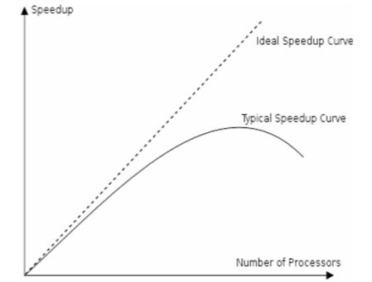

It measures how much speedup is brought per additional processor. Based on the typical speedup curve shown in the figure above, it is evident that typically efficiency will be decreased upon increase in the number of processors. The concept of scalability cannot be computed but evaluated. A parallel system is said to be scalable when the algorithm and/or the hardware can easily incorporate and take advantage of more processors. This term is viewed as nebulous , since it depends on the target problem, algorithm applied, hardware, current system load, and numerous other factors. Generally, programs and hardware are said to be scalable when they can take advantage of hundreds or even thousands of processors.

1. **Methodology**

Parallel and Distributed Computing (PDC) relies on systematic approaches to efficiently execute computational tasks across multiple processors or distributed systems. The methodologies can be broadly categorized into the following:

* 1. **Task Decomposition**

Problems are divided into smaller, independent tasks that can be executed concurrently.

**4.1.1 Types of decomposition:**

**Functional decomposition**: Divides tasks based on operations or functions.

**Data decomposition**: Divides tasks based on subsets of data.

**4.2 Parallel Execution Models**

**Shared Memory Model**:

Multiple processors access a common memory space. Synchronization mechanisms like locks and semaphores are used to prevent conflicts.

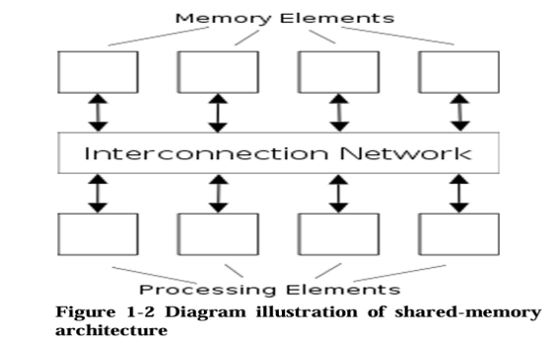

**Distributed Memory Model**:

Each processor has its own local memory, and communication occurs through message passing. 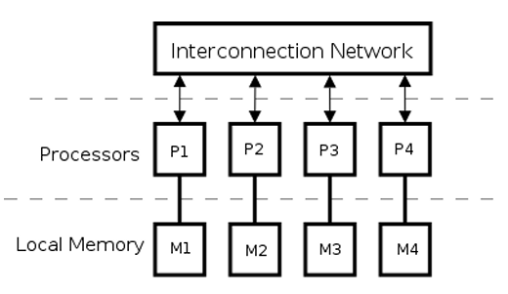

**4.3 Scheduling and Load Balancing**

Proper scheduling ensures tasks are assigned to processors efficiently to minimize idle time.

Load balancing distributes workloads evenly across processors or nodes to maximize performance.

**4.4. Communication and Synchronization**

Communication protocols manage data exchange between processors or distributed nodes.

Synchronization mechanisms ensure correct execution order and prevent race conditions in parallel tasks.

**3.5. Fault Tolerance and Reliability**

echniques like **checkpointing**, **replication**, and **recovery protocols** maintain system reliability in case of hardware or network failures.

Essential for distributed systems where node failures are common

**3.6. Hybrid Methodologies**

Modern PDC systems often combine shared and distributed memory models to leverage the benefits of both architectures.

Examples include multi-core nodes in a cluster or cloud-based high- performance computing systems.

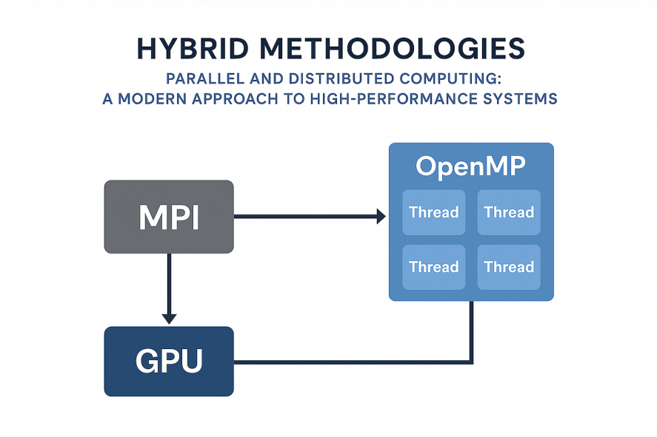

## ****Applications****

Parallel and Distributed Computing has applications across various domains:

**5.1. Scientific Research** – Climate modeling, molecular dynamics, and space simulations.

**5.2. Big Data Analytics** – Tools like Hadoop and Spark for large-scale data processing.

**5.3. Artificial Intelligence** – Training deep learning models on GPUs and distributed clusters.

**5.4. Cloud Computing** – Resource sharing and virtualization in AWS, Azure, and Google Cloud.

**5.5. Healthcare** – Genome sequencing and medical imaging analysis.

**6.6. Finance** – Real-time fraud detection and stock market predic

## ****Challenges and Limitations****

Despite its importance, PDC faces several challenges:

**6.1. Communication Overhead** – Increased latency in data transfer among distributed systems.

**6.2. Synchronization Issues** – Maintaining consistency across multiple processors or nodes.

**6.3. Load Balancing** – Uneven task distribution reduces efficiency.

**6.4. Scalability Limits** – Beyond a point, adding more processors does not improve performance.

**6.6. Fault Tolerance** – Ensuring system reliability in case of hardware or network failures.

**6.6. Energy Consumption** – Large-scale clusters consume significant power, raising sustainability concerns.

## ****Conclusion****

Parallel and Distributed Computing has transformed the landscape of modern computing by enabling high-performance processing and large-scale problem solving. Parallel computing enhances speed and efficiency, while distributed computing ensures scalability and reliability across interconnected systems. Together, they support cutting-edge fields such as big data, artificial intelligence, cloud services, and scientific simulations. Although challenges like synchronization, communication cost, and fault tolerance remain, ongoing research continues to develop more efficient algorithms, architectures, and frameworks. The future of computing lies in harnessing the combined power of parallelism and distribution to meet the growing demands of data-driven applications and intelligent systems.

## ****References****

[01] Grama, A., Gupta, A., Karypis, G., & Kumar, V. (2003). Introduction to Parallel Computing. Addison-Wesley.

[02] Tanenbaum, A. S., & Van Steen, M. (2017). Distributed Systems: Principles and Paradigms. Pearson.

[03] Dean, J., & Ghemawat, S. (2008). "MapReduce: Simplified Data Processing on Large Clusters." Communications of the ACM, 51(1).

[04] Foster, I. (1995). Designing and Building Parallel Programs. Addison-Wesley.

[05] Buyya, R., Vecchiola, C., & Selvi, S. T. (2013). Mastering Cloud Computing. McGraw-Hill.